​

*Information Technology Institute*

*.Net Full Stack Developer*

**Examination System**

Supervisor:

Eng. **Sarah Salah**

**Presented by:**

Ahmed Mohamed Abdelwahab

Ahmed Refaat Mohamed

Mohamed Ali Abdelhafez

DATABASE DESIGN (ERD)

Examination system ERD includes entities such as Student ,Instructor, Intake, department, students, questions, courses, grades and their relationships to each other.

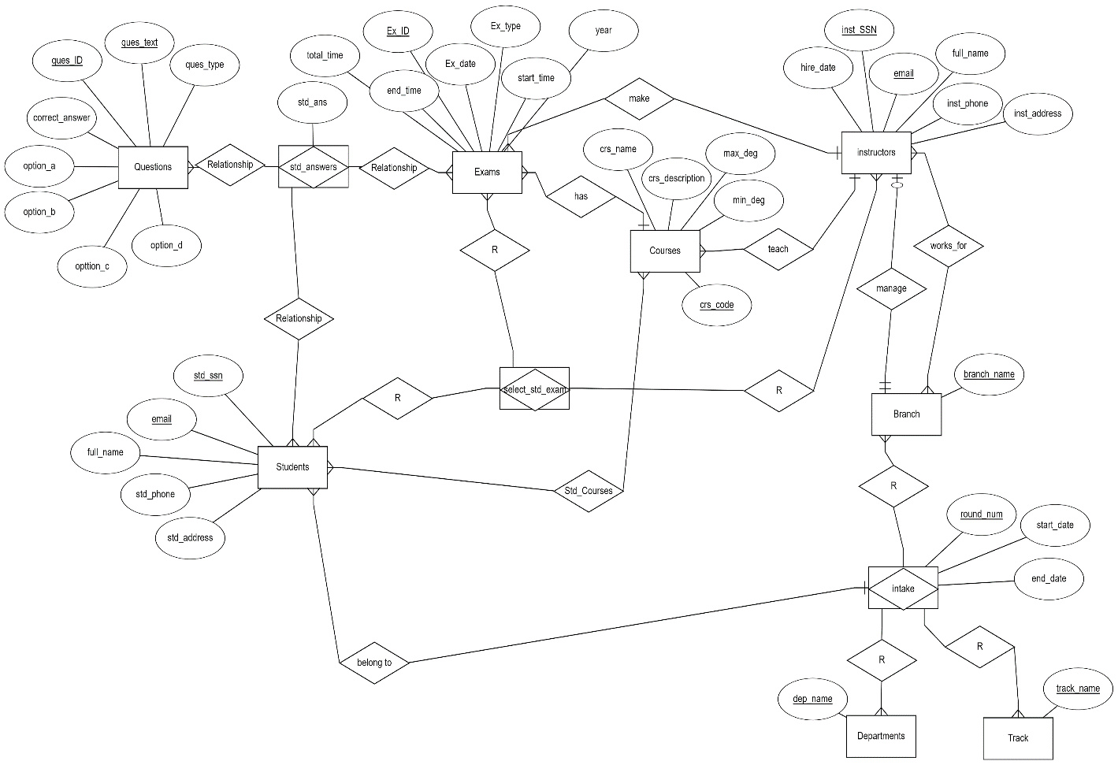

DATABASE DESIGN (MAPPING)

Mapping in the examination system refers to the process of creating a correspondence or association between different entities or attributes in the system needed to implement in the SQL Server Management Studio.

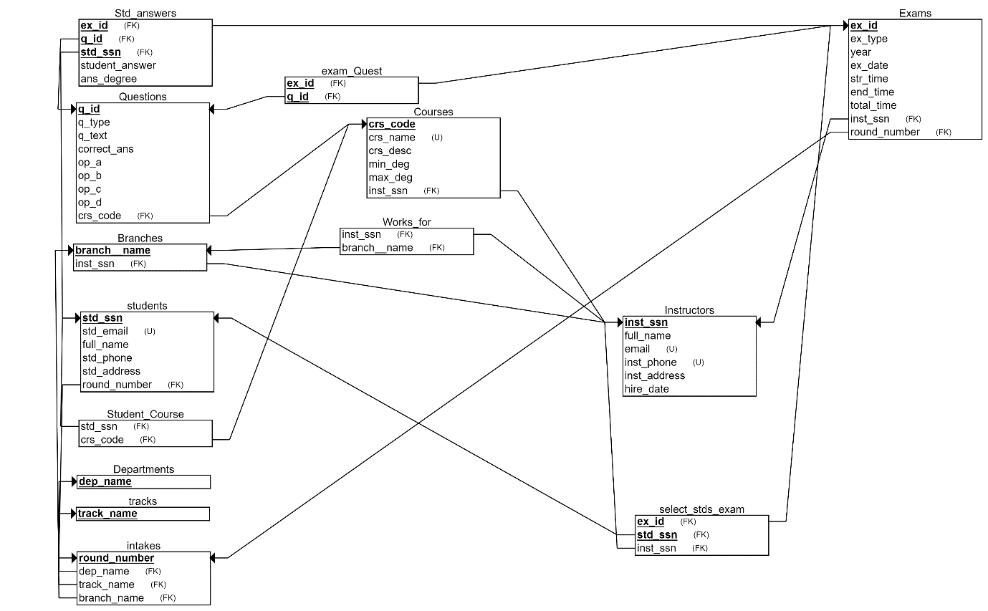

IMPLEMENTATION

Creating a database for an examination system typically involves defining tables to store information about the Topic, Course, Instructor, Student, Department, Exam Once we defined the table schema, we populated the tables with data. We used the Bulk Insert command. This command allows for the efficient insertion of large amounts of data into tables from a data file. The data file can be CSV in our system.

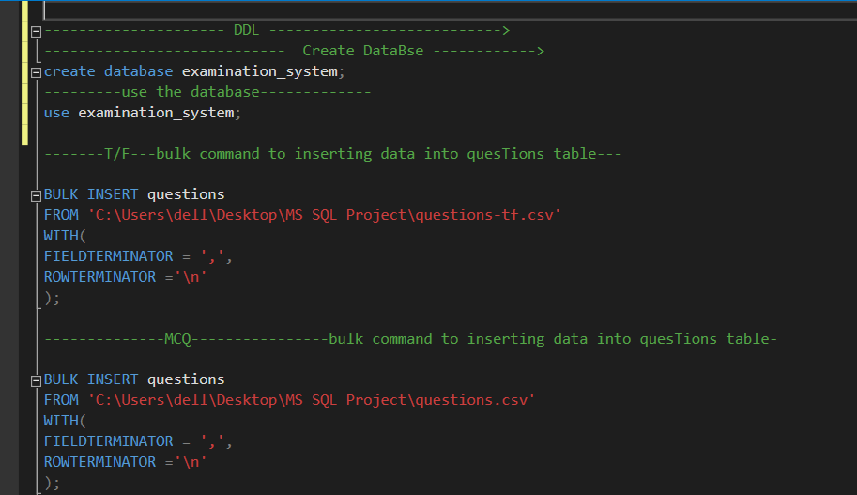

Data Snapshots

* Search About specific Cousre

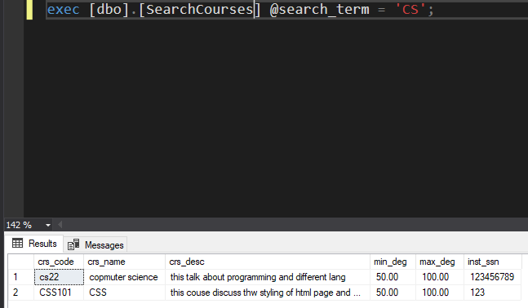

* Generate Exam by selecting rondom questions

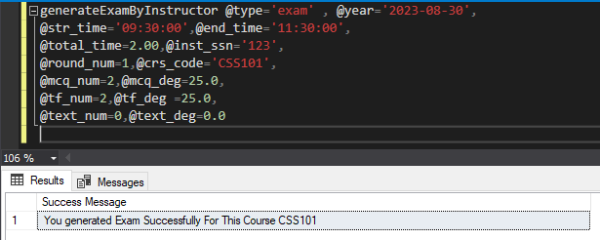

* Student display exam question in its specific time

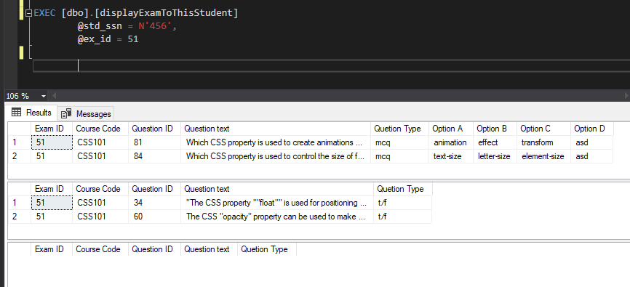

* Student Display his final result exam

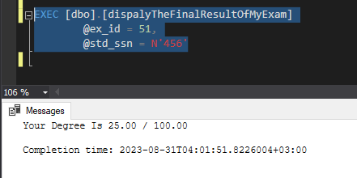

* Instructor display result of all students in specicf exam in his course.

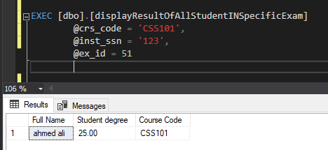

* Display student result in specific exam



* Example to check that permsions is working

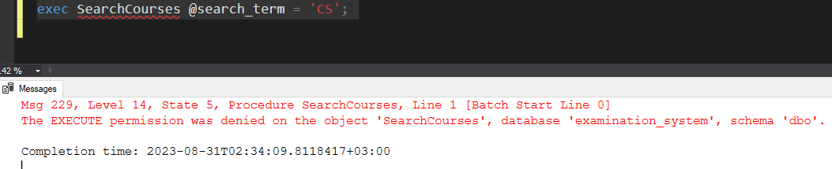

Instructor Procedures

* generateExamByInstructor

@type char(10), ----type Exam (exam , corrective)

@year date, ----------------(Date of an exam)

@str_time time(7), ----------Start time--------

@end_time time(7), ----------End time--------

@total_time numeric(2,1), --------total time of Exam ---------

@inst_ssn char(14), -----------Instructor SSN ---------

@round_num int, ------------intake round number -----

@crs_code varchar(25), ----------Course Code ---------

@mcq_num int, @mcq_deg numeric(2,1), ---Number of MCQ quesstions ----

@tf_num int, @tf_deg numeric(2,1), --------Number of t/f quesstions ----

@text_num int , @text_deg numeric(2,1) --Number of text quesstions

Instructors Generates an Exam with Rondom question From questions pool.

* CreateExamWithBasicInfo

@type char(10), ----type Exam

@year date, ----------------(Date of an exam)

@str_time time(7), ----------Start time--------

@end_time time(7), ----------End time--------

@total_time numeric(2,1), --------total time of Exam -----

@inst_ssn char(14), -----------Instructor SSN ---------

@round_num int, ------intake round number -----

@crs_code varchar(25) ------Course Code ----

Instructor Create Exam with The Basics Info.

* displayAllExamForCourseThatInstructorTeach

@inst_ssn char(14)

Instructor Proc to display all exam for his course teach

* displayAllQuestionsForCourseThatInstructorTeach

@inst_ssn char(14)

Instructor Proc to display all Questions for his course teach.

* SelectingQuestionToOneByOneExamManually

@ex_id int , ---Exam ID ---

@q_id int , ------Question ID ----

@q_degree numeric(2,1) -----Question Degree -----

Instructor Select the Exam and its Questions one by one.

* displayAllStudentThatEnrrolledInSpecCourse

@crs_code varchar(25)

instructor display all students that Enrolled in his course that he teach.

* displayResultOfAllStudentINSpecificExam

@crs_code varchar(25),

@inst_ssn char(14),

@ex_id int

Instructor Display Result of All Student In his Course.

Student Procedures

* displayExamToThisStudent

@std_ssn char(14),

@ex_id int

This procedure allow student to do and see his Exam in its specific time.

* answerQuestionToSpecificExam

@ex_id int ,

@q_id int,

@std_ssn CHAR(14),

@std_answer varchar(100)

This procedure allow student to answer exam’s Question in exam time.

* updateAnswerQuestionToSpecificExam

@ex_id int ,

@q_id int,

@std_ssn CHAR(14),

@new_std_answer varchar(100)

This procedure allow student to update his answer exam’s Question in exam time.

* dispalyTheFinalResultOfMyExam

@ex_id int,

@std_ssn char(14)

This procedure allow student to display his result

In this exam after the exam is expired.

Manager Procedures

* PROCEDURE AddCourse

@crs_code VARCHAR(25),

@crs_name NVARCHAR(50),

@crs_desc VARCHAR(MAX),

@min_deg numeric(18, 0),

@max_deg numeric(18, 0),

@inst_ssn CHAR(14)

It allows the training manager to add new courses through the following parameters and by checking and ensuring that the data is correct and does not conflict with the requirements and conditions of the system.

* PROCEDURE DeleteCourse

@crs_code VARCHAR(25)

It allows the training manager to Delete course through the following parameter and by checking and ensuring that the data is correct and does not conflict with the requirements and conditions of the system.

* PROCEDURE UpdateCourse

@crs_code VARCHAR(25),

@NewCourseName VARCHAR(50),

@NewCourseDesc VARCHAR(MAX),

@NewMinDeg numeric(18, 0),

@NewMaxDeg numeric(18, 0),

@NewInstSsn CHAR(14)

It allows the training manager to Upate course data through the following parameter and by checking and ensuring that the data is correct and does not conflict with the requirements and conditions of the system.

* PROCEDURE SearchCourses

@search_term NVARCHAR(100)

It allows to Search about course through the following parameter and by checking and ensuring that the data is correct and does not conflict with the requirements and conditions of the system.

* PROCEDURE SearchStudents

@search_term NVARCHAR(100)

It allows to Search about Instructor through the following parameter and by checking and ensuring that the data is correct and does not conflict with the requirements and conditions of the system.

* CREATE PROCEDURE Addinstructor

@instssn CHAR(14),

@Name VARCHAR(50),

@Email VARCHAR(50),

@Phone VARCHAR(11),

@Adress VARCHAR(100),

@Hiredate DATE  
  
It allows the training manager to add new Instructors through the following parameters and by checking and ensuring that the data is correct and does not conflict with the requirements and conditions of the system.

* CREATE PROCEDURE UpdateInstructor

@instssn CHAR(14),

@NewName VARCHAR(50),

@NewEmail VARCHAR(50),

@NewPhone VARCHAR(11),

@NewAddress VARCHAR(100),

@NewHiredate DATE

It allows the training manager to Update in Instructors Data through the following parameters and by checking and ensuring that the data is correct and does not conflict with the requirements and conditions of the system.

* CREATE PROCEDURE DeleteInstructor @instssn CHAR(14)

It allows the training manager to Delete Instructor through the following parameter and by checking and ensuring that the data is correct and does not conflict with the requirements and conditions of the system.

## *this procedure can create a New intakes*

alter procedure add_new_intake

@round_num int , @str_date date, @end_date date , @dep_name varchar(100) , @track_name varchar(100) ,@branche_name varchar(100)

It allows the training manager to add new intakes through the following parameters and by checking and ensuring that the data is correct and does not conflict with the requirements and conditions of the system.

### *this procedure can delete exist intake*

alter procedure delete_intake (@round_num int )

It allows the training manager to delete intakes through the following parameters and by checking and ensuring that the data is correct and does not conflict with the requirements and conditions of the system.

* procedureupdate_intake_info

(@round_num int ,

@str_date date,

@end_date date ,

@dep_name varchar(100) ,

@track_name varchar(100) ,

@branch_name varchar(100))

It allows the training manager to updating intakes information through the following parameters and by checking and ensuring that the data is correct and does not conflict with the requirements and conditions of the system.

* procedure add_new_student

@std_ssn char(14) ,

@str_email varchar(50),

@full_name varchar(50) ,

@std_phone char(11) ,

@std_address varchar(100) ,

@round_num int)

It allows the training manager to add new students through the following parameters and by checking and ensuring that the data is correct and does not conflict with the requirements and conditions of the system.

* procedure delete_student

@std_ssn char(14)

It allows the training manager to delete students through the following parameters and by checking and ensuring that the data is correct and does not conflict with the requirements and conditions of the system.

* procedure update_student_info

(@std_ssn char(14) ,

@std_email varchar(50),

@full_name varchar(50) ,

@std_phone char(11) ,

@std_address varchar(100) ,

@round_num int)

It allows the training manager to updating students informations through the following parameters and by checking and ensuring that the data is correct and does not conflict with the requirements and conditions of the system.

* procedure ADD_BRANCHES

(@branch_name as varchar(100),

@inst_ssn as char(14))

It allows the training manager to add new branches through the following parameters and by checking and ensuring that the data is correct and does not conflict with the requirements and conditions of the system.

* procedure delete_branch

@branch_name varchar(100)

It allows the training manager to delete branches through the following parameters and by checking and ensuring that the data is correct and does not conflict with the requirements and conditions of the system.

* procedure update_branch_info

(@branch_name varchar(100),

@inst_ssn char(14) ,

@new_branch_name varchar(100) ,

@new_inst_ssn char(14))

It allows the training manager to updating branches informations through the following parameters and by checking and ensuring that the data is correct and does not conflict with the requirements and conditions of the system.

* procedure ADD_TRACKS

(@TRACK_name as varchar(100))

It allows the training manager to add new trackes through the following parameters and by checking and ensuring that the data is correct and does not conflict with the requirements and conditions of the system.

* procedure delete_track

@track_name varchar(100)

It allows the training manager to delete trackes through the following parameters and by checking and ensuring that the data is correct and does not conflict with the requirements and conditions of the system.

* procedure update_track_info

(@old_track_name as varchar(100),

@new_track_name as varchar(100))

It allows the training manager to updating trackes informations through the following parameters and by checking and ensuring that the data is correct and does not conflict with the requirements and conditions of the system.

* PROCEDURE ADD_DEPARTMENT

(@DEPARTMENT_NAME as varchar(100))

It allows the training manager to add new Departments through the following parameters and by checking and ensuring that the data is correct and does not conflict with the requirements and conditions of the system.

* procedure delete_department

@DEPARTMENT_NAME varchar(100)

It allows the training manager to delete departments through the following parameters and by checking and ensuring that the data is correct and does not conflict with the requirements and conditions of the system.

* procedure update_department_info

(@old_department_name varchar(100) ,

@new_department_name varchar(100))

It allows the training manager to updating departments informations through the following parameters and by checking and ensuring that the data is correct and does not conflict with the requirements and conditions of the system.

* procedure add_question_pool

(@inst_ssn char(14),

@q_id int ,

@q_text varchar(max),

@crs_code varchar(25),

@q_type varchar(5),

@correct_ans varchar(100),

@op_a varchar(100) ,

@op_b varchar(100),

@op_c varchar(100) ,

@op_d varchar(100))

This allows the instructor to add questions related to his course only and does not allow him to add any questions in the rest of the courses

* PROCEDURE Ubdate_Question

@inst_ssn char(14),

@q_id int ,

@q_text varchar(max),

@crs_code varchar(25),

@q_type varchar(5),

@correct_ans varchar(100),

@op_a varchar(100),

@op_b varchar(100),

@op_c varchar(100),

@op_d varchar(100))

This allows the instructor to updating questions related to his course only and does not allow him to updating any questions in the rest of the courses.

* procedure delete_question

@inst_ssn char(14), @q_id int ,

@crs_code varchar (25)

This allows the instructor to delete questions related to his course only and does not allow him to delete any questions from the rest of the courses.

Manager Views

* displayAllInstructors

View To allow manager to Display all Instructor.

* displayAllStudents

View To allow manager to Display all students.